Information for Dads

As found on the Moira Shire Council website>Residents>Maternal and Child Health>Programs and Services>Information for Dads

A child’s welfare and development benefits when fathers take an active and positive role in the care and nurturing of their families.

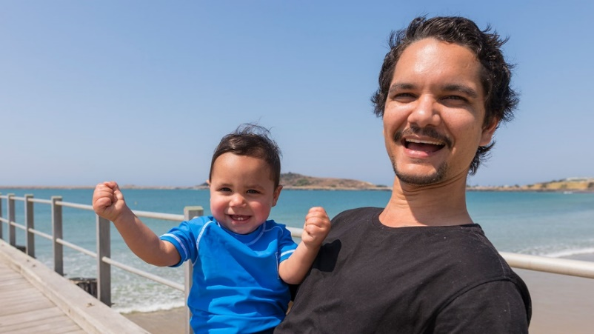
Here are some resources to support dads in their important role:

Topic | Links
Congratulations you're a dad | New Baby Manual for Dads - https://www.relationshipsvictoria.com.au/assets/PDFs/centcarebabymanual.pdf
Blogs | Best Aussie Daddy Bloggers Down Under - https://www.facebook.com/AussieDaddyBloggers
Aboriginal and ATSI Resources | I’m An Aboriginal Dad - https://healthinfonet.ecu.edu.au/key-resources/programs-and-projects/430/  Aboriginal and Torres Strait Islander Dads - https://raisingchildren.net.au/guides/first-1000-days/resources-for-Aboriginal-and-Torres-Strait-Islander-parents/indigenous-dads  Learning About Being A Father - https://wydac.org.au/home/strong-fathers-aaron-patrick/
Apps | SMS4dads - https://www.sms4dads.com.au/  What Were We Thinking? - https://www.jeanhailes.org.au/what-were-we-thinking
Men's Health Resources | Raising Children - Fathers - https://raisingchildren.net.au/grown-ups/fathers  Dadvice for new dads - https://healthyfamilies.beyondblue.org.au/pregnancy-and-new-parents/dadvice-for-new-dads  Men's Line Australia - https://mensline.org.au/  Beyond Blue - https://www.beyondblue.org.au/who-does-it-affect/men  How is Dad going? - https://www.panda.org.au/info-support/how-is-dad-going  Tweedle - Parent Resources - https://www.tweddle.org.au/our-work/parent-info-hub/
Breastfeeding Information for fathers | Especially for partners - https://www.breastfeeding.asn.au/bf-info/general-breastfeeding-information/especially-partners  We're in this together... the breastfeeding partnership - https://www.breastfeeding.asn.au/bfinfo/we%E2%80%99re-together-%E2%80%A6-breastfeeding-partnership
Family Violence Support and Services | No To Violence Men's Referral Service - https://ntv.org.au/  Men's Behaviour Change Program - https://www.relationshipsvictoria.com.au/services/familyviolence/MBCP/
Books | Men at Birth - edited by David Vernon  The Dad Factor - by Richard Fletcher  What Happens Now? - by Nick Carr
