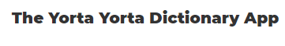
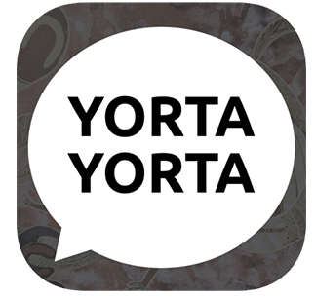

This resource has been developed by Sharon Atkinson and WCC Language Program. All information will remain the property of the Yorta Yorta people. Explore and learn the language and culture of the Yorta Yorta people anywhere in the world, for free! Browse the dictionary by letter, categories and common phrases. Search in Yorta Yorta and English.

